~Asia-China-Mirror-Yuan Dynasty-Bloom And Bird Pattern Bronze Mirror

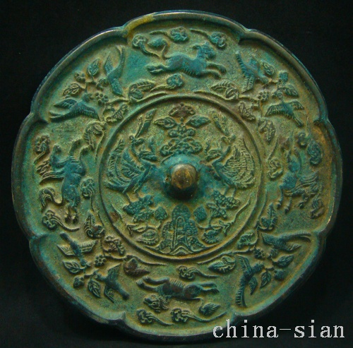

Diameter 141  mm     Deep  4.5  mm